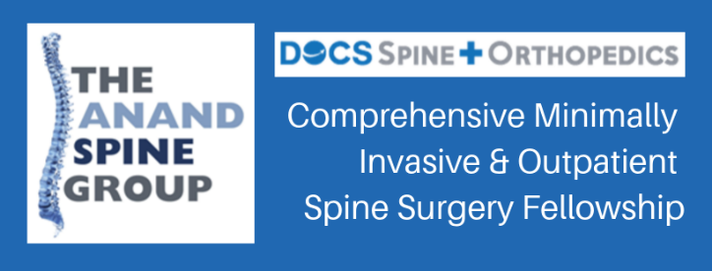 | Neel Anand, MD  444 S. San Vicente Blvd, Suite 901  Los Angeles, CA 90048  P: 310-423-9779  F: 310-423-9773

Applicant Information
Full Name: |  |  |  | Date:
 | Last | First | M.I.

Address:
 | Street Address | Apartment/Unit #

 | City | State | ZIP Code

Phone: |  | Email | :

Requested Start Date: |  | February | August | Year:

Education
College: |  | City/State:

From: |  |  | To: |  | Degree:
Medical School: |  |  |  |  |  |  | City/State:

From: |  |  | To: |  | Degree:
Residency: |  |  |  |  |  |  | City/State:

From: |  |  | To: |  | Program Director:
Fellowship: |  |  |  |  |  |  | City/State:

From: |  | To: |  | Program Director:

Spine Experience
Please provide details of your experience in spine surgery thus far, including commonly performed procedures and surgeons under whom you have trained.

Minimally Invasive Fellowship
Please describe your interest in applying for the Comprehensive Minimally Invasive & Outpatient Spine Surgery Fellowship.

Please list which minimally invasive or outpatient spine procedures you are most attracted to incorporating into your practice.

Research
Please propose 2-3 topics of research in which you would like to participate in during this fellowship.

Practice
Please list where you would like to practice upon completion of the fellowship. Please note, fellows are expected to pursue practice outside of the Los Angeles area.

Disclaimer and Signature
I certify that my answers are true and complete to the best of my knowledge.
If this application leads to employment, I understand that false or misleading information in my application or interview may result in my release.

Signature: |  | Date:

